# CS 255 System Design Document

**Matthew R. Leclerc**

**Southern New Hampshire University**

**8/10/23**

## UML Diagrams

### UML Use Case Diagram

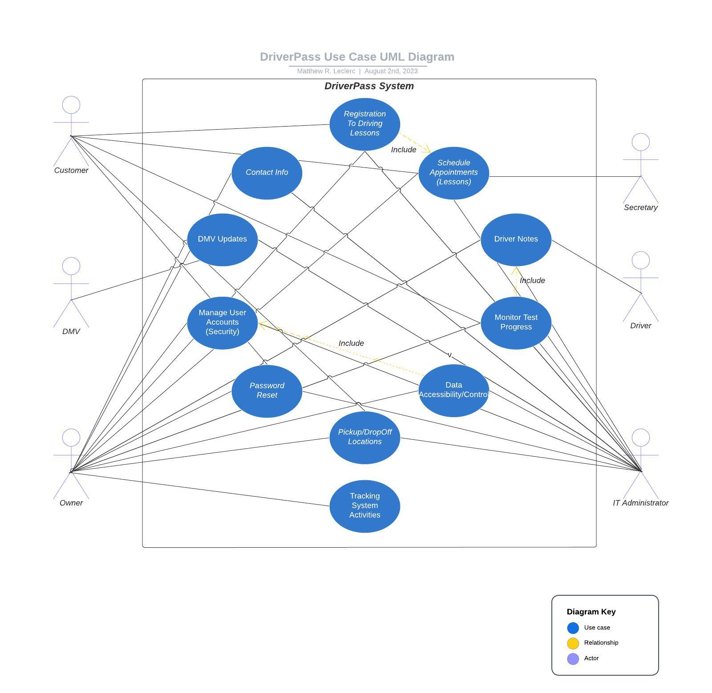

### UML Activity Diagrams

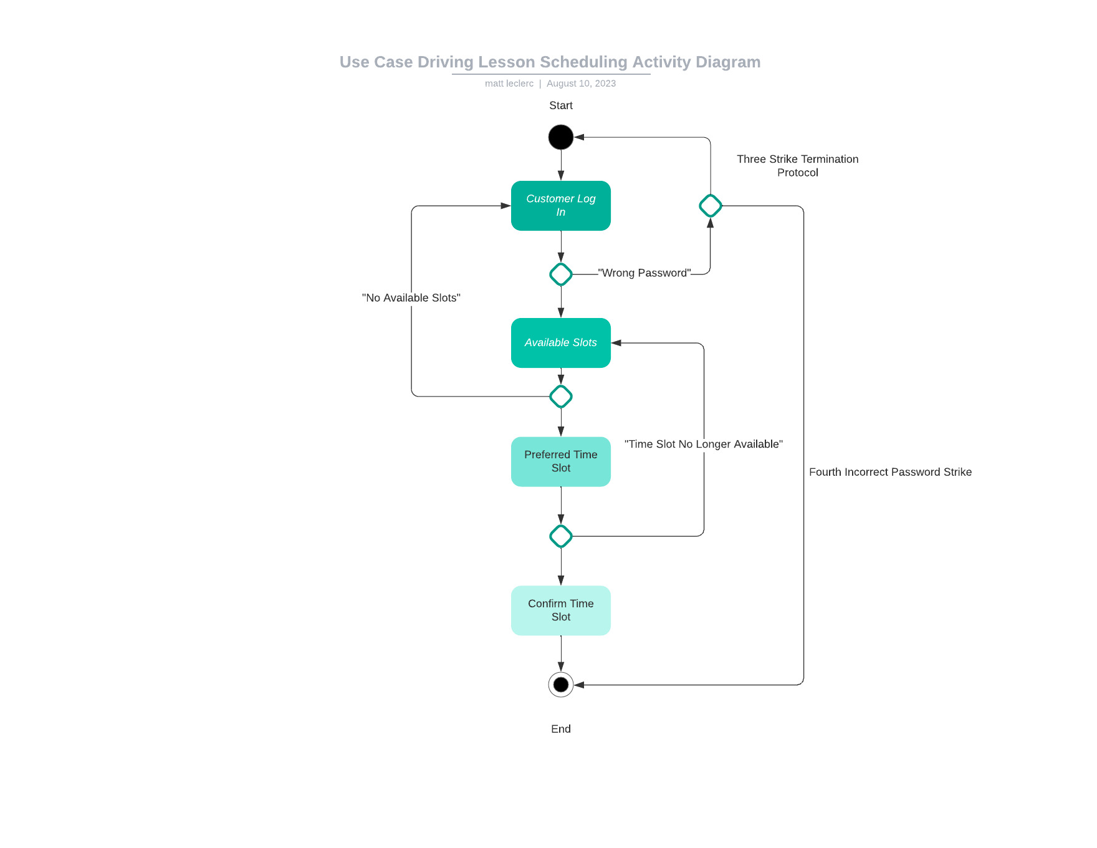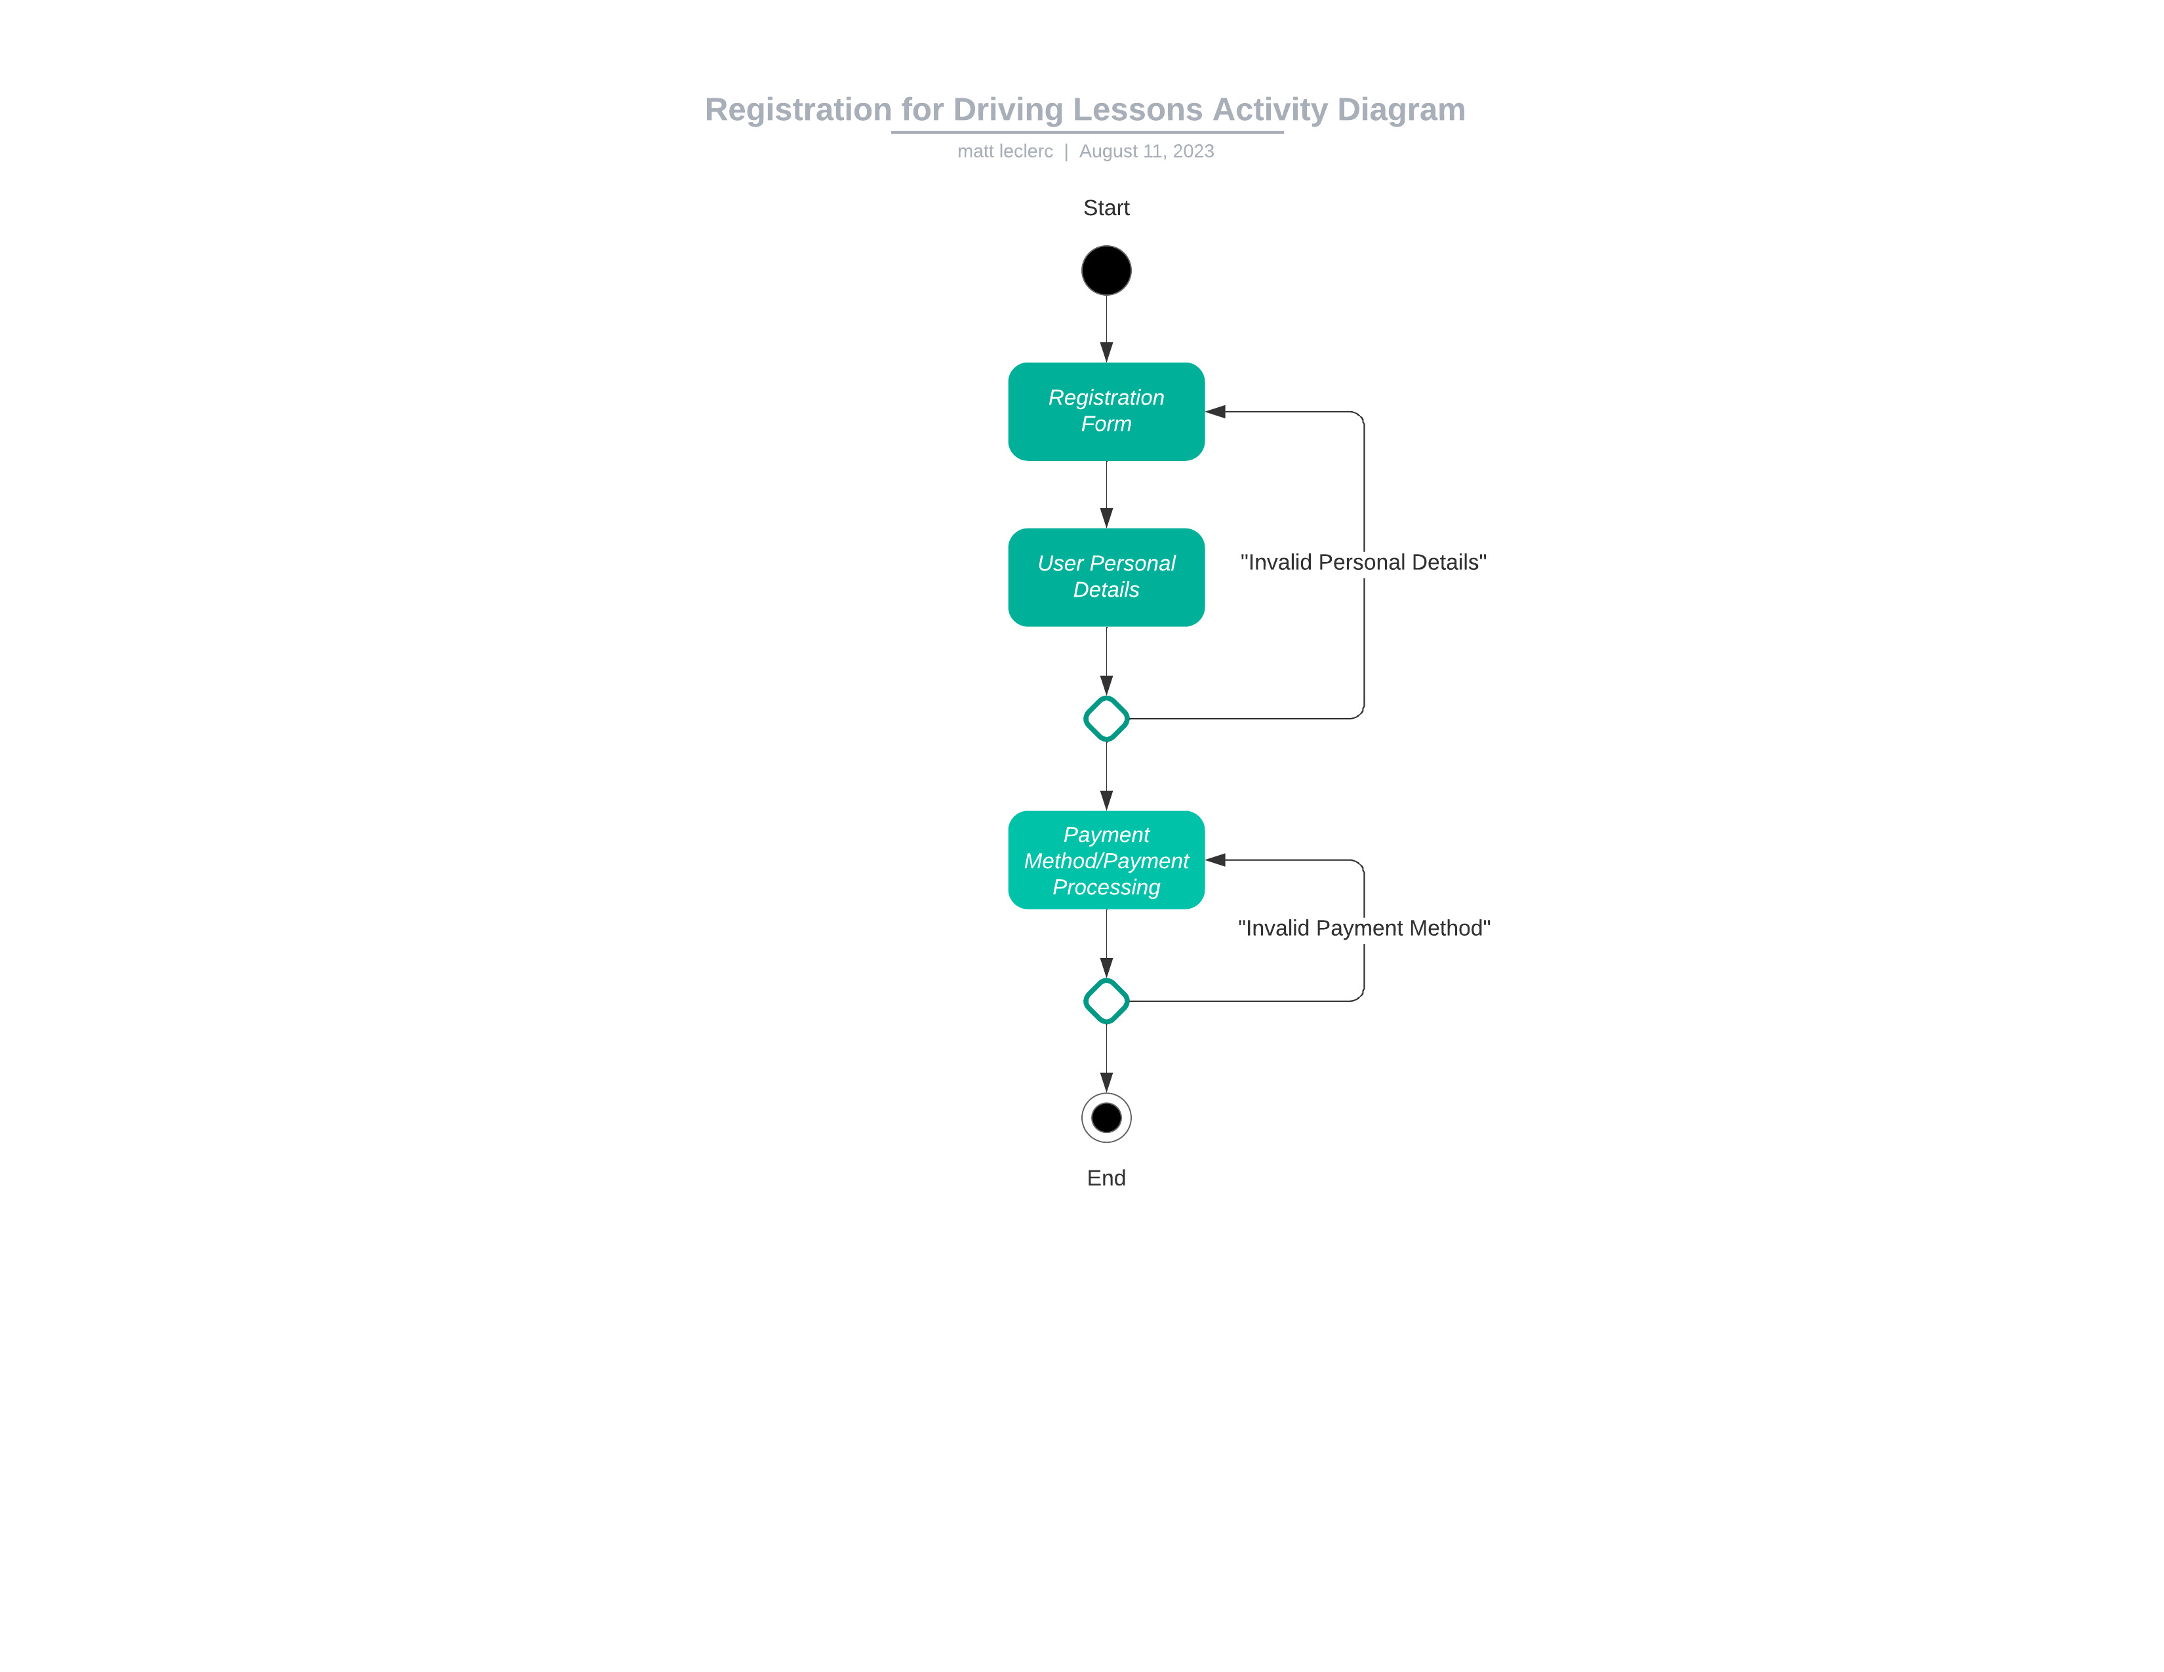

### UML Sequence Diagram

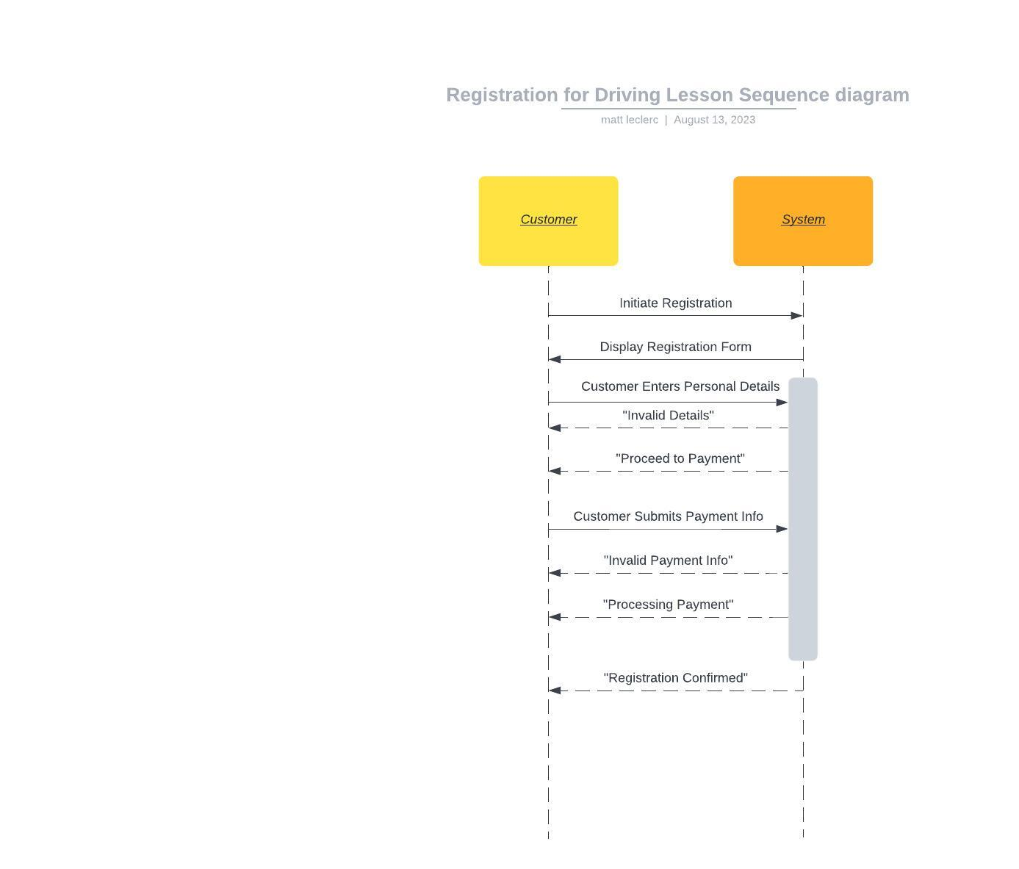

### UML Class Diagram

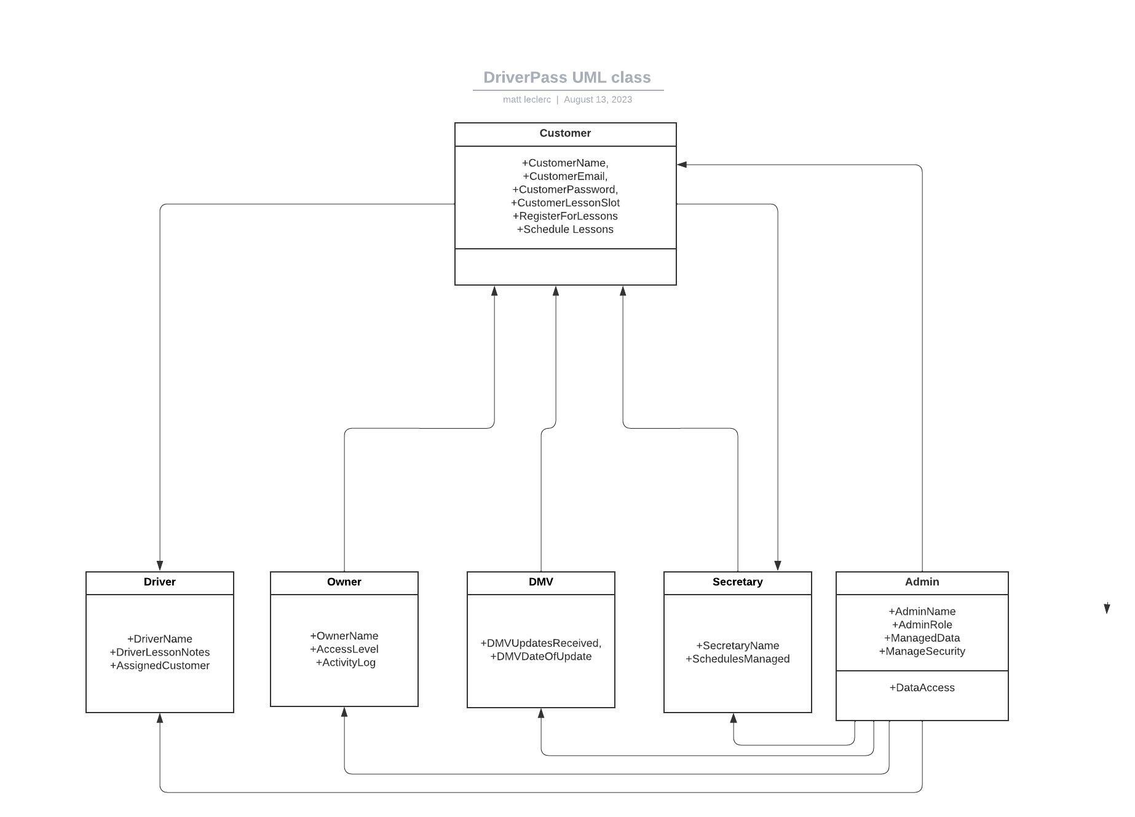

## Technical Requirements

*The DriverPass system is designed to offer a comprehensive suite of features ensuring a smooth interface for all users and system administrators. Central to its functionality, the system allows users to sign up, log in, personalize their profiles, and efficiently book their driving lessons. Moreover, it provides clear insights into users' test advancements and allows instructors to input crucial feedback from lessons. Prioritizing user satisfaction, specific nonfunctional criteria have been determined. The system aims for rapid responsiveness, targeting a two-second maximum delay for user interactions. The utmost importance is given to data security and consistency; therefore, it undergoes daily backups and integrates advanced encryption, particularly for delicate financial information. Embracing accessibility, the platform is tailored to accommodate individuals with disabilities. On the technical side, the system is anchored by high-performance servers, backed by auxiliary servers for fail-safe operations. Staff members at the driving school will access the system through advanced workstations, while instructors use mobile tools to input data in real-time.*